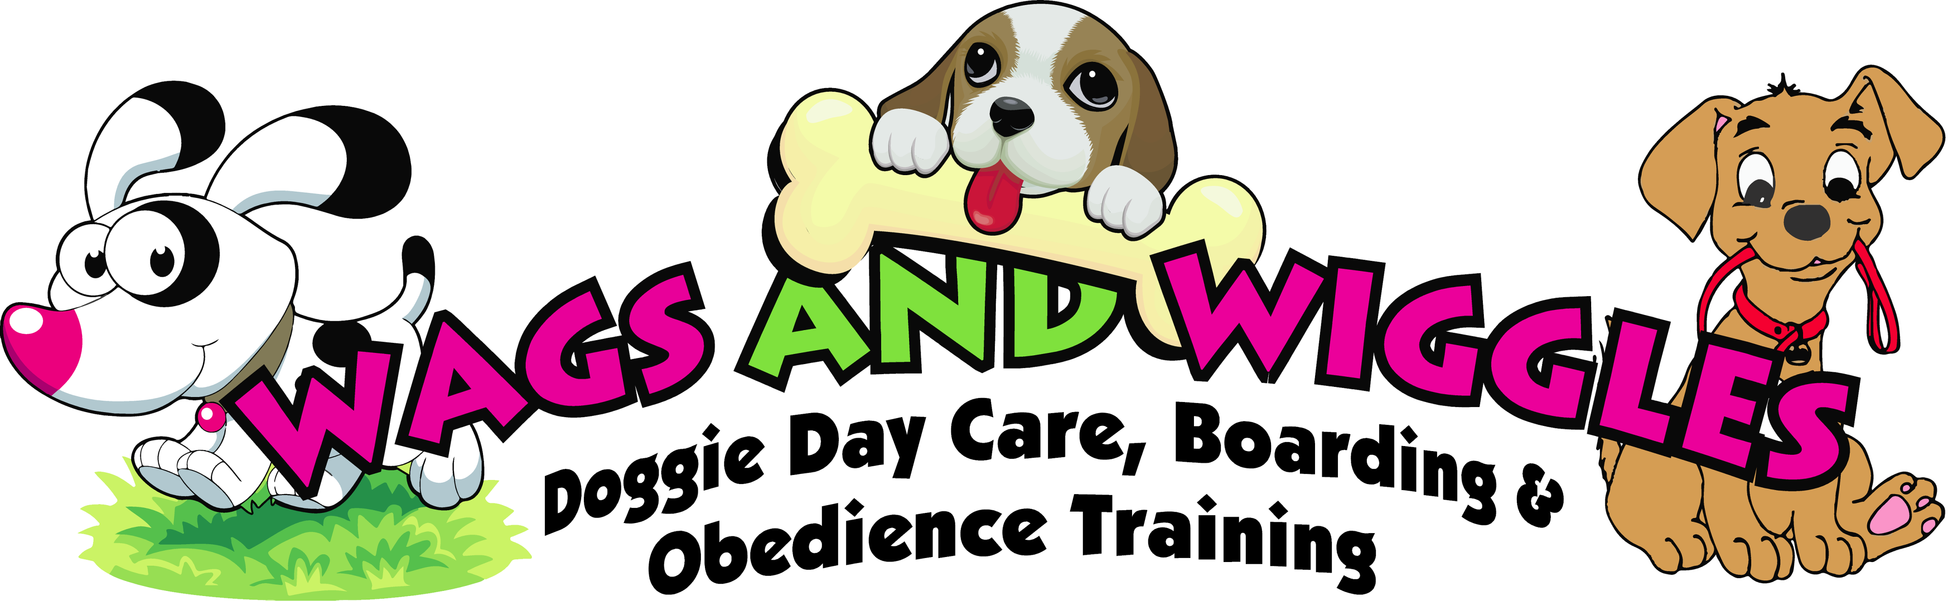
CLIENT AGREEMENT
Please read the items below and sign indicating approval.
- I understand that I am responsible for payment for services rendered at Wags and Wiggles, LLC.
- I understand at this time Wags and Wiggles only accepts CASH OR CHECK as form of payment.
- If collections proceedings are necessary, I will be responsible for any and all attorney’s fee.
- A $25.00 fee will be charged on any returned checks.
- I will not hold Wags and Wiggles, LLC, the owners or employees responsible for any damages or loss incurred by participating in said Doggie Day Care/Boarding program.
- It is my responsibility to make sure that my dog is properly vaccinated. I understand that even though all dogs attending Wags and Wiggles are properly vaccinated, the possibility of illness still exists. No vaccine is 100% effective.
- I understand that during communal dog play all groups are closely monitored by staff; however, there are risks involved such as but not limited to scrapes and cuts, which can be commonplace due to nature of dog play. Most serious injuries cannot be predicted. I do hereby give permission to Wags and Wiggles, LLC employees or a veterinarian to administer treatment to my dog. I understand that an employee from Wags and Wiggles, LLC will do his or her best to contact me prior to treatment.
- I have been informed and understand Wags and Wiggles hours of operation. If I am late, I am responsible to contact Wags and Wiggles employee. I understand a $ 5.00 fee for every 5 minutes after closing will be assessed. After a 15 minute waiting period is exhausted, my dog will be boarded overnight and I will be charged overnight boarding fees in addition to the above mentioned fees.

Signature:___________________________________________Date:_______________

Wags and Wiggles Owner/Employee:________________________________________

